Glider Activity

Subject:  Related Subjects: | Grade Level(s):  Length of Lesson: | Type: Inquiry / Design / Project  Keywords:

Lesson Overview
Use this section to describe at a high level what the lesson is. Should be no more than 3-4 lines.

Lesson Focus
What is the central question or phenomenon being investigated? What problem are they trying to solve?

Lesson Objective(s) | By the end of this lesson, students will…  - Learn the concepts of attraction, repulsion, friction, polarity, and charge.

Lesson Timing

5 minutes | Introduce the Lesson
30 minutes | ...

Materials | - Material 1 (# per student, per group of # students, per class)
Instructor Prep | - Step 1
Related Resources | - For more detailed explanations you may visit:  http://www.grc.nasa.gov/WWW/K-12/airplane/index.html  http://travel.howstuffworks.com/airplane.htm  - For additional gliders and planes you may visit:  http://www.paperairplanes.co.uk/planes.php  http://www.paperairplanes.co.uk/gliders.php

Lesson Plan

Introduction
There are four principle components of flight: thrust, drag, lift and gravity. Thrust is a force that moves the object through space. It can be externally applied or result from an internal source. Drag is the wind resistance on the object as it moves through space. Lift typically results from airflow passing over the surface of the wings. Gravity is the natural force that pulls the object down. In order to achieve flight, Thrust must exceed drag and lift must exceed gravity.

Gravity

Thrust

Drag

Lift

A common theory of lift derives from Bernoulli’s Equation, the air moving above a typical airplane’s wing (angled toward ascent) is moving faster than that below. This creates a reduced pressure above the wing causing the wing to move up (lift) in response to the pressure difference. Another theory derives from Newton’s Third Law (action-reaction) is the air hitting the bottom of the wing (because it is at an angle) forcing the air down and the lifting the wings up. (Students have experienced this when they have placed their hand outside the window of a moving car. Be extremely careful when doing this). In fact the theory of lift comes from a combination of both. However, the actual theory is far too complex to simplify in terms of either theory.

The paper glider utilizes thrust (throwing motion), drag (wind resistance), and gravity. Lift, however, is caused by buoyancy. The air exerts and upward force equal to the weight of the air displaced by the glider. An increase in the surface area/weight ratio of the glider increases the air displaced by the glider and consequently the amount of lift. The force of gravity acts upon the airplane’s center of gravity. The aerodynamic forces of lift and drag act upon the airplanes center of pressure. Airplanes are designed so that their center of gravity is near, but slightly in front of, their center of pressure.

To find center of gravity, COG, hold plane perpendicular to finger and balance. Add weight to change location of COG. To find the center or pressure, COP, trace the outline of the paper plane onto the manila folder. (This is easiest if you put the plane upside down on the folder.) Cut out the shape of the airplane. You have just made a cut-out with the shape of the shadow of the airplane. Balance the cut-out on your finger. The COP of the plane is located over your finger

Variables

Wings

For given shape vary 1. span and 2. cord lengths (calculate aspect ratio : optimal ½ optimal, twice optimal

Fuselage
Vary 3. length optimal ½ optimal, twice optimal

Dihedral
4. 0 45 90

Angle of attack

Measure
time, and distance, COG and COP

Procedure
Create a paper airplane, launch, make modifications and observe

- Fold 1 sheet of paper lengthwise in half and crease.

- Unfold sheet, and then fold top ends toward center crease line until a triangle is formed at the top and crease.

- Fold top triangle portion down creasing at the bottom of the triangle (top of paper.

- Fold new top ends (bottom of top triangle portion) toward center until they touch approximately ½ inch from triangle point. Top of paper should be flat (approx. 1 inch).

- Fold pointed end of folded triangle over two touching points.

- Backwards fold (away from you) and crease. The folded pointed end should form a pouch and should be on outside.

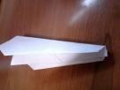
- Fold both angled ends until they align with bottom of glider.

- Extend wings and place tape on wings above pouch.

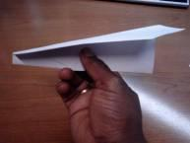

Activity 2 – Airplane 1
- Launch paper airplane 3 times, from a 45º angle and measure each time in the air.
- Calculate average time

Length  (cm) | Wingspan  (cm) | COP (cm from tail) | COG (cm from tail) | Launch Angle  (deg) | Time 1  (s) | Time 2  (s) | Time 3  (s) | Avg Time  (s)

- Keeping wingspan and launch angle the same, change the length. You will need to re-measure the COP and COG because they will change with the change in length.
Length  (cm) | Wingspan  (cm) | COP (cm from tail) | COG (cm from tail) | Launch Angle  (deg) | Time 1  (s) | Time 2  (s) | Time 3  (s) | Avg Time  (s)

- Keeping length and launch angle the same, change the wingspan. You will need to re-measure the COP and COG because they will change with the change in wingspan
Length  (cm) | Wingspan  (cm) | COP (cm from tail) | COG (cm from tail) | Launch Angle  (deg) | Time 1  (s) | Time 2  (s) | Time 3  (s) | Avg Time  (s)

- Keeping all of the other original measurements the same, change the location of the center of gravity
Length  (cm) | Wingspan  (cm) | COP (cm from tail) | COG (cm from tail) | Launch Angle  (deg) | Time 1  (s) | Time 2  (s) | Time 3  (s) | Avg Time  (s)

- Keeping all of the other original measurements the same, change the launch angle
Length  (cm) | Wingspan  (cm) | COP (cm from tail) | COG (cm from tail) | Launch Angle  (deg) | Time 1  (s) | Time 2  (s) | Time 3  (s) | Avg Time  (s)

- Create paper airplane 2 and measure its parameters
- Launch paper airplane 3 times, from a 45º angle and measure each time in the air.
- Calculate average time

Length  (cm) | Wingspan  (cm) | COP (cm from tail) | COG (cm from tail) | Launch Angle  (deg) | Time 1  (s) | Time 2  (s) | Time 3  (s) | Avg Time  (s)

- Keeping wingspan and launch angle the same, change the length. You will need to re-measure the COP and COG because they will change with the change in length.
Length  (cm) | Wingspan  (cm) | COP (cm from tail) | COG (cm from tail) | Launch Angle  (deg) | Time 1  (s) | Time 2  (s) | Time 3  (s) | Avg Time  (s)

- Keeping length and launch angle the same, change the wingspan. You will need to re-measure the COP and COG because they will change with the change in wingspan
Length  (cm) | Wingspan  (cm) | COP (cm from tail) | COG (cm from tail) | Launch Angle  (deg) | Time 1  (s) | Time 2  (s) | Time 3  (s) | Avg Time  (s)

- Keeping all of the other original measurements the same, change the location of the center of gravity
Length  (cm) | Wingspan  (cm) | COP (cm from tail) | COG (cm from tail) | Launch Angle  (deg) | Time 1  (s) | Time 2  (s) | Time 3  (s) | Avg Time  (s)

- Keeping all of the other original measurements the same, change the launch angle
Length  (cm) | Wingspan  (cm) | COP (cm from tail) | COG (cm from tail) | Launch Angle  (deg) | Time 1  (s) | Time 2  (s) | Time 3  (s) | Avg Time  (s)

- Create cardstock glider – The wings, vertical stabilizer and horizontal stabilizers are all trapezoids. The fuselage should be 4 sheets thick. All other components 1 sheet. Attach the components with tape.

  - Fuselage (body)
iii

ii

i

    - 25cm
    - 2.5cm
    - 1cm
i

  - Wings – each

    - 5cm
    - 10cm
    - 3cm
  - Vertical stabilizer (tail)
    - 4cm
ii

    - 5cm
    - 2cm
  - Horizontal stabilizers (fins) – each
    - 3cm
    - 5cm
    - 2cm

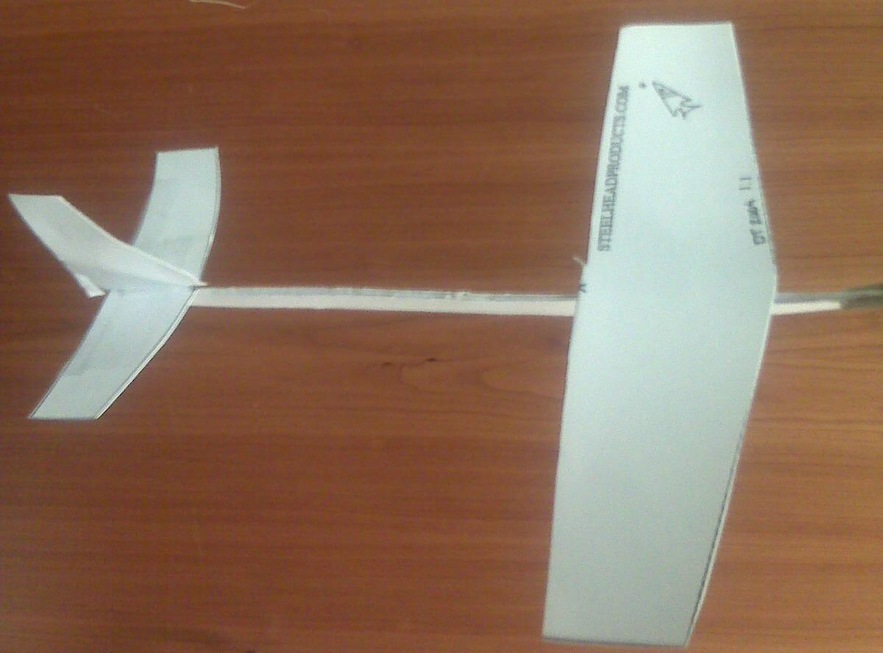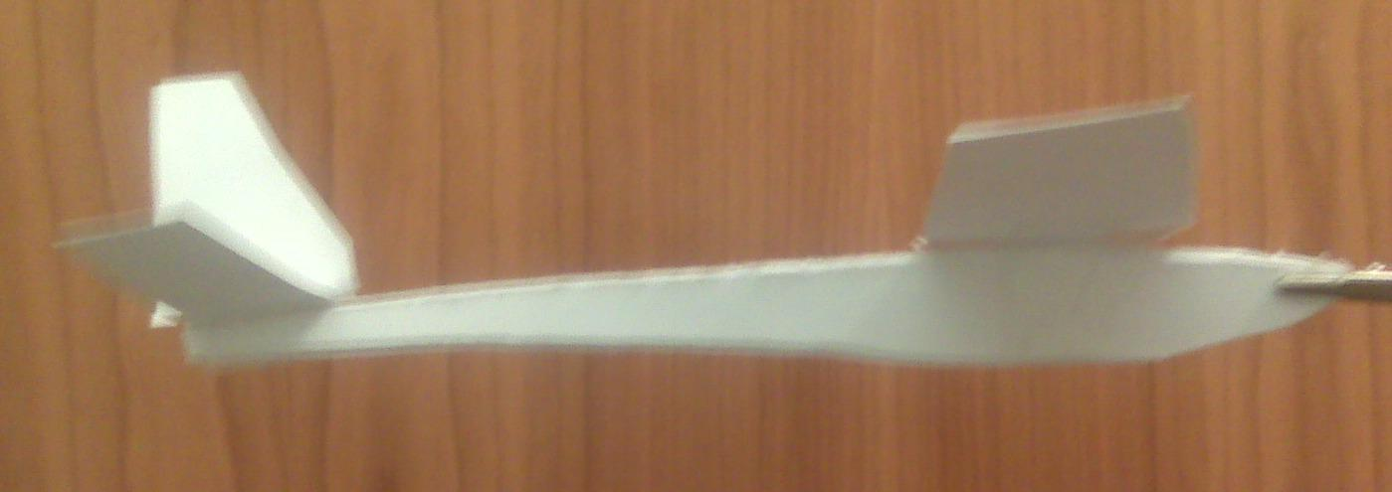
iii

- Calculate average time

Length  (cm) | Wingspan  (cm) | COP (cm from tail) | COG (cm from tail) | Launch Angle  (deg) | Time 1  (s) | Time 2  (s) | Time 3  (s) | Avg Time  (s)

- Keeping wingspan and launch angle the same, change the fuselage length. You will need to re-measure the COP and COG because they will change with the change in length of fuselage.
Length  (cm) | Wingspan  (cm) | COP (cm from tail) | COG (cm from tail) | Launch Angle  (deg) | Time 1  (s) | Time 2  (s) | Time 3  (s) | Avg Time  (s)

- Keeping length and launch angle the same, change the length of the wings. You will need to re-measure the COP and COG because they will change with the change in the length of wings
Length  (cm) | Wingspan  (cm) | COP (cm from tail) | COG (cm from tail) | Launch Angle  (deg) | Time 1  (s) | Time 2  (s) | Time 3  (s) | Avg Time  (s)

- Keeping all of the other original measurements the same, change the location of the center of gravity
Length  (cm) | Wingspan  (cm) | COP (cm from tail) | COG (cm from tail) | Launch Angle  (deg) | Time 1  (s) | Time 2  (s) | Time 3  (s) | Avg Time  (s)

- Keeping all of the other original measurements the same, change the launch angle
Length  (cm) | Wingspan  (cm) | COP (cm from tail) | COG (cm from tail) | Launch Angle  (deg) | Time 1  (s) | Time 2  (s) | Time 3  (s) | Avg Time  (s)

- Create a second cardstock glider using a different shape and size for the wings, vertical stabilizer and horizontal stabilizer and record its parameters.
- Launch cardstock glider 3 times, from a 45º angle and measure each time in the air.
- Calculate average time

Length  (cm) | Wingspan  (cm) | COP (cm from tail) | COG (cm from tail) | Launch Angle  (deg) | Time 1  (s) | Time 2  (s) | Time 3  (s) | Avg Time  (s)

- Keeping wingspan and launch angle the same, change the fuselage length. You will need to re-measure the COP and COG because they will change with the change in length of fuselage.
Length  (cm) | Wingspan  (cm) | COP (cm from tail) | COG (cm from tail) | Launch Angle  (deg) | Time 1  (s) | Time 2  (s) | Time 3  (s) | Avg Time  (s)

- Keeping length and launch angle the same, change the length of the wings. You will need to re-measure the COP and COG because they will change with the change in the length of wings
Length  (cm) | Wingspan  (cm) | COP (cm from tail) | COG (cm from tail) | Launch Angle  (deg) | Time 1  (s) | Time 2  (s) | Time 3  (s) | Avg Time  (s)

- Keeping all of the other original measurements the same, change the location of the center of gravity
Length  (cm) | Wingspan  (cm) | COP (cm from tail) | COG (cm from tail) | Launch Angle  (deg) | Time 1  (s) | Time 2  (s) | Time 3  (s) | Avg Time  (s)

- Keeping all of the other original measurements the same, change the launch angle
Length  (cm) | Wingspan  (cm) | COP (cm from tail) | COG (cm from tail) | Launch Angle  (deg) | Time 1  (s) | Time 2  (s) | Time 3  (s) | Avg Time  (s)

Wrap-up
End the lesson with some final discussions about what students designed/discovered. Connect their activity back to the focus question/problem, real world examples, and STEM careers.

Also include notes about any special cleanup considerations

Lesson Background for Teachers

Suggested Real-World STEM Connections
- List possible related Role Models in STEM (with details and links to more reading). Give suggestions for examples of scientists/engineers who are from underrepresented groups in STEM in related careers.
- List related real-world engineering problems and examples

Lesson Variations and Options
Include descriptions of alternative methods or ways to present things.

Explanation
Describe the background concepts and explanations behind the lesson. This can be more in depth than a teacher/instructor would actually share with students.

Key Concepts and Vocabulary
Thrust
Gravity
Bernoulli
Newton
Center of Pressure
Center of Gravity
- Dihedral angle
Angle of attack (launch angle)
- Aspect ratio
Chord (root and tip)
Span

Safety Notes
- Safety instruction

